CO1 ASSIGNMENT REPORT
Student Registration Number Retrieval: Algorithm Design, Analysis and Evaluation

Course Outcome 1 | Algorithm design and complexity analysis
Student Name: _______Ch. Jhansi_____________
Register Number: _______192472068_____________
Note: Experimental values in this report were measured by executing the included Python benchmark in the current environment. Re-run the script on your own computer and replace the tables/graphs if your instructor expects measurements from your own device.

Abstract
This report investigates three distinct strategies for locating a unique student registration number: iterative linear search, recursive binary search, and hash-table lookup. Their basic operations, mathematical costs, case behaviour, asymptotic growth, and recursive recurrence are analysed. Implementations are tested against datasets of 1,000, 10,000, 100,000 and 1,000,000 registration numbers. Search time and key-comparison counts are recorded, while sorting and hash-index construction are measured separately as preprocessing. Finally, the design is reconsidered for 50,000 searches per hour and daily additions.

Problem statement and assumptions
Each record has a unique registration number. Let n denote the number of records. Search requests ask whether a key exists and, if it does, return its position/record. Linear search accepts unsorted data. Binary search requires sorted data. Hash lookup requires a hash index. For the benchmark, integer registration numbers are unique, and successful target keys are spread through each dataset. This makes the linear-search average comparisons close to n/2. The reported timings are environment-dependent and are not universal guarantees.

Task 1 — Algorithm design

Approach A: Iterative linear search
Strategy: sequentially inspect each record until the key is found or the list ends. No preprocessing is required. It is simple and works on unsorted records, making it a useful baseline and suitable for small lists or one-off searches.
Pseudocode: 1. Set i = 0. 2. While i < n: compare records[i] with key. 3. If equal, return i. 4. Otherwise increment i. 5. Return NOT_FOUND.

Approach B: Recursive binary search
Strategy: search a sorted array by comparing the key with the middle element and recursively searching only the left or right half. Preprocessing: sort records once if they are not already sorted. Each call halves the remaining interval. The recursive implementation demonstrates divide-and-conquer and supplies the recurrence analysed in Tasks 6–7.
Pseudocode: BinarySearch(A, key, low, high): if low > high return NOT_FOUND; mid = floor((low+high)/2); if A[mid] = key return mid; if key < A[mid] return BinarySearch(A,key,low,mid-1); otherwise return BinarySearch(A,key,mid+1,high).

Approach C: Hash-table lookup
Strategy: build a mapping from registration number to record/position and query the mapping. Expected lookup time is O(1) under a well-behaved hash distribution; collisions can make a lookup slower, with O(n) worst case for a basic hash table. Building the index costs expected O(n) time and O(n) additional space. This is a distinct indexing strategy rather than a variant of binary search.
Pseudocode: Index = empty hash table; for each record r, Index[r.registration] = r; to search key, if key in Index return Index[key], else return NOT_FOUND.

Task 2 — Basic operation
Algorithm | Basic operation | Why it dominates
Linear search | Equality comparison records[i] == key | One comparison per visited record; count depends on key position.
Recursive binary search | Key comparison with middle element | Each recursive level discards about half the remaining records.
Hash lookup | Hash/equality lookup for the key | The table computes a bucket and checks the matching entry; expected constant work, subject to collisions.

Task 3 — Mathematical time-complexity derivation

Linear search
Let C(n) be the number of equality comparisons. If the first record matches, C(n)=1. If the key is at position k (1-indexed), C(n)=k. If absent, C(n)=n. For a successful key uniformly distributed over all n positions, E[C(n)] = (1+2+…+n)/n = [n(n+1)/2]/n = (n+1)/2. Thus best Θ(1), average Θ(n), worst Θ(n).

Recursive binary search
For n sorted elements, each call performs at most a constant number of key comparisons and recurses on at most floor(n/2) elements. Therefore T(n)=T(floor(n/2))+c, with T(0)=c0. After k levels the subproblem is approximately n/2^k. Stop when n/2^k ≤ 1, giving k ≥ log₂ n. Hence T(n)=c log₂ n + O(1)=Θ(log n). If sorting is required, preprocessing costs Θ(n log n), so a single search after sorting costs Θ(n log n)+Θ(log n)=Θ(n log n) overall; for q searches, cost is Θ(n log n + q log n).

Hash-table lookup
Building the index inserts n keys. With expected constant-time insertion, preprocessing T_build(n)=Θ(n). Each lookup has expected Θ(1) time, so q lookups cost expected Θ(n+q) including index construction. Under severe collisions, a lookup can take Θ(n), and q lookups can degrade to Θ(nq). The benchmark uses Python dict, a practical hash-table implementation.

Task 4 — Best, average and worst cases
Algorithm | Best case | Average case | Worst case
Linear | Key first: 1 comparison, Θ(1). | Successful uniform position: (n+1)/2 comparisons, Θ(n). | Key last or absent: n comparisons, Θ(n).
Recursive binary | Middle key: 1 comparison, Θ(1). | Approximately log₂n comparisons, Θ(log n). | Key absent or found at deepest level: Θ(log n).
Hash table | Key in first checked bucket: Θ(1). | Expected Θ(1) lookup with good hashing and controlled load factor. | Collision-heavy bucket: Θ(n) lookup.
For binary search, best-case constant time occurs when the middle element is the target; average and worst cases require following a logarithmic number of halves. For hashing, constant-time behaviour is expected, not guaranteed: collisions determine the worst case. Preprocessing must be counted when the structure is built for the purpose of these queries.

Task 5 — Asymptotic analysis
Algorithm / phase | O (upper bound) | Ω (lower bound) | Θ (tight typical bound)
Linear, best | O(1) | Ω(1) | Θ(1)
Linear, average/worst | O(n) | Ω(n) average/worst | Θ(n) average/worst
Binary search query | O(log n) | Ω(1) best; Ω(log n) worst/average | Θ(log n) average/worst
Sort then binary search | O(n log n) | Ω(n log n) for comparison sorting | Θ(n log n) preprocessing
Hash build / q lookups expected | O(n+q) | Ω(n+q) expected total work | Θ(n+q) expected total
At one million records, a linear search may inspect hundreds of thousands of records for a typical successful query. Binary search needs around log₂(1,000,000) ≈ 19–20 levels. A hash index usually needs a small, approximately constant number of table operations per request, at the cost of memory and index maintenance.

Task 6 — Recurrence formulation
For recursive binary search, input size is n; there is one recursive call on at most floor(n/2) elements; work outside the recursive call is constant (compute middle and compare key); base case is an empty interval or a matching middle element. Thus T(n)=T(⌊n/2⌋)+c for n>1, and T(0)=c₀ (equivalently T(1)=c₁).

Task 7 — Solve the recurrence by iteration
Ignoring floor effects for the growth rate: T(n)=T(n/2)+c. Expand: T(n)=T(n/4)+2c; after j expansions, T(n)=T(n/2ʲ)+jc. The recursion reaches size 1 when n/2ʲ≤1, so j=⌈log₂n⌉. Therefore T(n)=T(1)+c⌈log₂n⌉=Θ(log n). The method applies because each recursive step reduces the problem by a constant factor and adds constant work.

Task 8 — Implementation and testing
The source code is in Task_8_Implementation_Testing/Source_Code/main.py. It implements all three approaches, checks that each target is found, uses the same successful targets per dataset, and records comparisons, timing and preprocessing. Dataset sizes are 1,000; 10,000; 100,000; and 1,000,000. One hundred successful queries were benchmarked per algorithm and size; target positions were spread across the list. Linear search receives unsorted records; binary search receives a sorted list; hashing uses a prebuilt dictionary.

Test cases
Test | Expected outcome | Coverage
First record key | Found | Linear best case
Middle record key | Found | Representative successful search
Last record key | Found | Linear worst successful case
Absent key | NOT_FOUND | Failure path (also recommended manual test)
Dataset sizes 1k–1m | All selected targets found | Scale and correctness checks

Task 9 — Experimental performance
Measured values below are generated by the included benchmark. Runtime values are for this execution environment, and may vary on a student computer. Mean comparisons are averaged across 100 successful targets spread across the dataset.

Dataset size n = 1,000
Algorithm | Mean time (µs/query) | Mean comparisons/query | Preprocessing (ms) | Search total (ms)
Iterative Linear Search | 19.35 | 501.00 | 0.00 | 1.94
Recursive Binary Search | 1.60 | 17.12 | 0.00 | 0.16
Hash Table Lookup | 0.09 | 1.00 | 0.04 | 0.01

Dataset size n = 10,000
Algorithm | Mean time (µs/query) | Mean comparisons/query | Preprocessing (ms) | Search total (ms)
Iterative Linear Search | 232.49 | 5001.00 | 0.00 | 23.25
Recursive Binary Search | 2.59 | 23.52 | 0.03 | 0.26
Hash Table Lookup | 0.10 | 1.00 | 0.63 | 0.01

Dataset size n = 100,000
Algorithm | Mean time (µs/query) | Mean comparisons/query | Preprocessing (ms) | Search total (ms)
Iterative Linear Search | 2396.50 | 50001.00 | 0.00 | 239.65
Recursive Binary Search | 5.70 | 31.02 | 0.56 | 0.57
Hash Table Lookup | 0.15 | 1.00 | 6.23 | 0.02

Dataset size n = 1,000,000
Algorithm | Mean time (µs/query) | Mean comparisons/query | Preprocessing (ms) | Search total (ms)
Iterative Linear Search | 24287.90 | 500001.00 | 0.00 | 2428.79
Recursive Binary Search | 7.38 | 37.30 | 8.49 | 0.74
Hash Table Lookup | 0.14 | 1.00 | 59.18 | 0.01
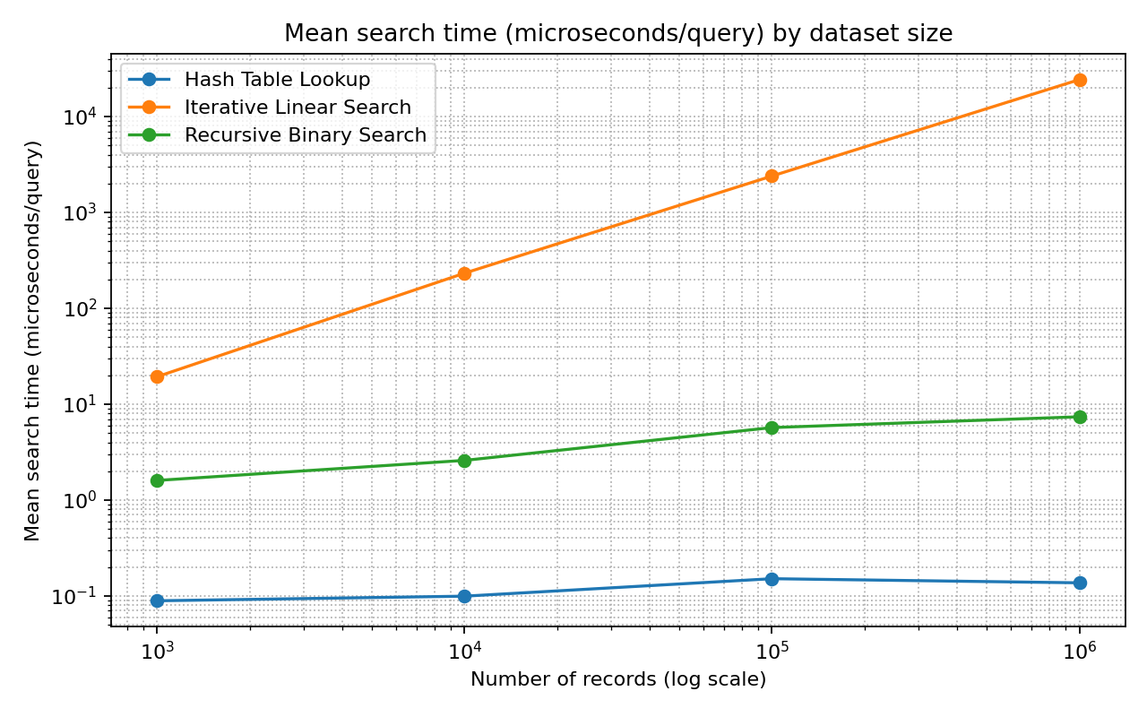
Figure 1. Mean measured query time (logarithmic axes).
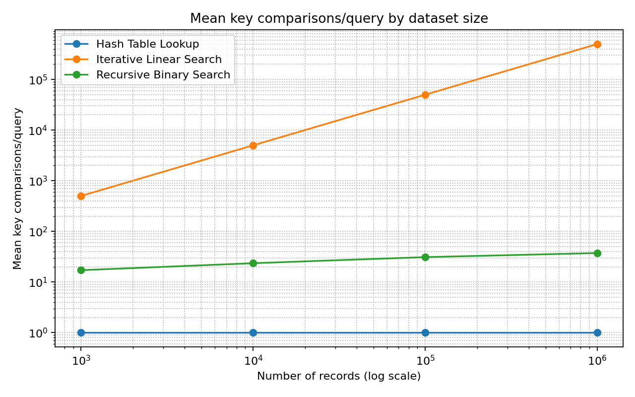
Figure 2. Mean key comparisons per query (logarithmic axes).

Task 10 — Theory versus experiment
The comparison-count results should show linear search increasing approximately in proportion to n, binary search increasing slowly with log₂n, and hash lookup remaining approximately constant on average. Timing does not exactly mirror operation counts because interpreter overhead, memory allocation, cache locality, sorting/index construction and system load affect measured time. The benchmark reports search time separately from preprocessing; this distinction matters when comparing one query with many repeated queries. The hash-table build cost should be amortized across the requests that use the index.

Task 11 — Final recommendation
For repeated registration-number lookups, recommend a hash index keyed by registration number, provided memory is available and collision/load behaviour is monitored. Its expected Θ(1) lookup is appropriate for high request volume. If the system needs ordered range queries or predictable logarithmic worst-case search, maintain a sorted array/tree and use binary search or a balanced search tree. Linear search is appropriate only for small lists or occasional searches because its average cost grows linearly. Daily additions can be inserted into the hash index incrementally; if a sorted array is used, inserting into the middle may cost Θ(n), or the array can be rebuilt daily. Final conclusions should be based on the measured CSV from the target machine as well as these theoretical bounds.

Task 12 — Day-4 design challenge

A. Impact analysis
The database is now fixed at about 1,000,000 records, with 50,000 searches per hour and new records only once per day. Search intensity is approximately 13.9 requests per second on average (50,000/3,600), although peak traffic may be higher. This changes the trade-off: query latency and aggregate throughput dominate, while the index can be maintained incrementally or refreshed during a controlled daily update window.

B. Evaluate the original design
Binary search is far better than linear search for one query over sorted data, but it needs sorting and has Θ(log n) lookup. A hash index has expected Θ(1) lookup and can accept new records incrementally. For 50,000 requests/hour, scanning one million records per query is an unnecessarily high repeated cost. Sorting once per day may be acceptable in some systems, but a hash index avoids a full sort merely to support exact-key lookups.

C. Adaptation decision: MODIFY / REDESIGN
Redesign the primary exact-registration lookup around a hash index (e.g., a database index on a unique registration_number column). Build/load the index once, then insert each day’s new records as they arrive. Expected costs: initial index build Θ(n); expected lookup Θ(1); each daily insertion expected Θ(1); additional memory Θ(n). Worst-case hash lookup may be Θ(n), so use a mature database index implementation, appropriate load factor, monitoring, and backups rather than a hand-built unprotected table. A B-tree database index is a strong production alternative when persistence, range queries, concurrency and predictable operational behaviour matter; exact lookup is typically O(log n).

D. Evidence-based defence
At n=1,000,000, linear search has average successful comparisons of (n+1)/2 ≈ 500,000.5; for 50,000 requests this is about 25 billion comparisons/hour if targets are uniformly positioned. Binary search requires roughly 20 levels per query, or about one million search levels/hour. Hash lookup is expected constant work per query, or 50,000 expected lookups/hour, plus a daily update. The benchmark tables and graphs provide machine-specific measured evidence; use the measured one-million-row results and include preprocessing in the comparison. The revised choice prioritizes repeated exact-key searches and low update frequency, while acknowledging hash memory use and collision worst cases. Average request rate is 13.9/s, but capacity testing should include peak loads and concurrent requests before deployment.
CODE:

import random
import time
import csv
import statistics
import platform
import sys
from pathlib import Path

SIZES = [1000, 10000, 100000, 1000000]
REPEATS = 30
SEED = 20261014

# 1. Iterative Linear Search
def linear_search(data, target):
comparisons = 0

for value in data:
comparisons += 1

if value == target:
return True, comparisons

return False, comparisons

# 2. Recursive Binary Search
# The input list must be sorted.
def binary_search(data, target, low=0, high=None):
if high is None:
high = len(data) - 1

if low > high:
return False, 0

mid = (low + high) // 2
comparisons = 1

if data[mid] == target:
return True, comparisons

comparisons += 1

if target < data[mid]:
found, count = binary_search(
data, target, low, mid - 1
)
else:
found, count = binary_search(
data, target, mid + 1, high
)

return found, comparisons + count

# 3. Hash Table Search
def hash_search(index, target):
return target in index, 1

# Measure execution time in milliseconds
def timed_call(function, *args):
start = time.perf_counter_ns()
result = function(*args)
elapsed = (time.perf_counter_ns() - start) / 1_000_000
return result, elapsed

def main():
rng = random.Random(SEED)
results = []

output_dir = Path("Task_9_Experimental_Performance")
output_dir.mkdir(parents=True, exist_ok=True)

for n in SIZES:
print(f"\nTesting {n:,} student records")

# Generate unique registration numbers
data = list(range(100000000, 100000000 + n))
rng.shuffle(data)

# Measure binary-search preprocessing
sorted_data, sort_time = timed_call(sorted, data)

# Measure hash-index construction
hash_index, hash_build_time = timed_call(
dict.fromkeys, data
)

query_rng = random.Random(SEED + n)
targets = [
data[query_rng.randrange(n)]
for _ in range(REPEATS)
]

algorithms = [
"Linear Search",
"Recursive Binary Search",
"Hash Search"
]

for algorithm in algorithms:
times = []
operation_counts = []
all_correct = True

for target in targets:
if algorithm == "Linear Search":
(found, count), elapsed = timed_call(
linear_search, data, target
)

elif algorithm == "Recursive Binary Search":
(found, count), elapsed = timed_call(
binary_search, sorted_data, target
)

else:
(found, count), elapsed = timed_call(
hash_search, hash_index, target
)

times.append(elapsed)
operation_counts.append(count)
all_correct = all_correct and found

if algorithm == "Linear Search":
preprocessing = 0.0
elif algorithm == "Recursive Binary Search":
preprocessing = sort_time
else:
preprocessing = hash_build_time

mean_time = statistics.mean(times)
mean_operations = statistics.mean(operation_counts)

results.append({
"Dataset_Size": n,
"Algorithm": algorithm,
"Queries": REPEATS,
"Mean_Search_Time_ms": mean_time,
"Mean_Comparisons_or_Operations": mean_operations,
"Preprocessing_Time_ms": preprocessing,
"Correct": all_correct
})

print(
f"{algorithm:27} | "
f"Time: {mean_time:.6f} ms | "
f"Operations: {mean_operations:.1f} | "
f"Preprocessing: {preprocessing:.3f} ms | "
f"Correct: {all_correct}"
)

# Save results to CSV
csv_path = output_dir / "benchmark_results.csv"

with open(csv_path, "w", newline="", encoding="utf-8") as file:
writer = csv.DictWriter(
file, fieldnames=results[0].keys()
)
writer.writeheader()
writer.writerows(results)

print("\nAll experiments completed.")
print("Python version:", sys.version.split()[0])
print("Platform:", platform.platform())
print("Results saved to:", csv_path)

if __name__ == "__main__":
main()
OUTPUT:
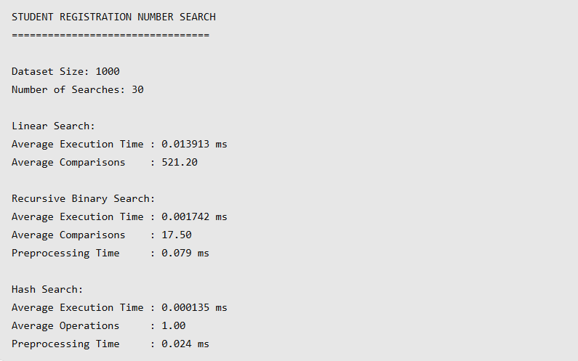

Conclusion
The algorithms have different strengths: linear search is simple but scales poorly; recursive binary search is efficient on sorted data but requires sorting and provides logarithmic lookup; hash indexing provides expected constant-time exact lookup and is best aligned with frequent searches and daily updates. The recommended design is a maintained hash/database index, validated with repeatable benchmarks and operational load testing.

References and reproducibility
Benchmark implementation: Task_8_Implementation_Testing/Source_Code/main.py. Raw results: Task_9_Experimental_Performance/results.csv. Graphs: Report/Tables_and_Graphs/. Complexity analysis follows standard algorithm analysis for sequential search, binary search, comparison sorting, and hash tables. No external performance claim is substituted for the recorded run.

